LAB 1

DEPLOYING DVWA WEBSITE ON THE LINUX SERVERS

Objective
Students will learn to:
- Install and configure a LAMP stack (Linux, Apache, MySQL/MariaDB, PHP)
- Download and deploy DVWA
- Configure required permissions and database settings
- Test and verify DVWA deployment

Prerequisites
- A working Ubuntu Server (20.04+ recommended)
- Internet access
- Root or sudo privileges
Note: Depending on the Linux distribution, the command line may be different.
Note: Command explaination is highlighted in yellow.

PART 1. Deploying the website on a server

Step 1: Update the Server
sudo apt update && sudo apt upgrade -y
To download and apply the latest version of kali linux

Step 2: Install Apache, MySQL, and PHP (LAMP Stack)
sudo apt install apache2 mysql-server php php-mysqli php-gd libapache2-mod-php git -y
Replace the command above with:
sudo apt install apache2 mariadb-server php php-mysql php-gd libapache2-mod-php git -y
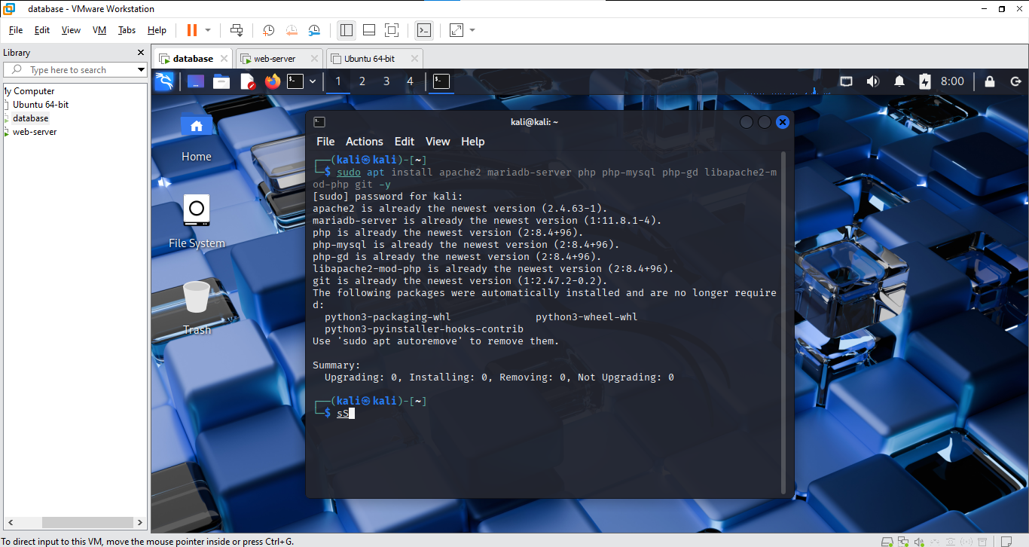
sudo systemctl enable apache2
sudo systemctl start apache2
sudo systemctl status apache2: to show apache2 status(turned on or not)
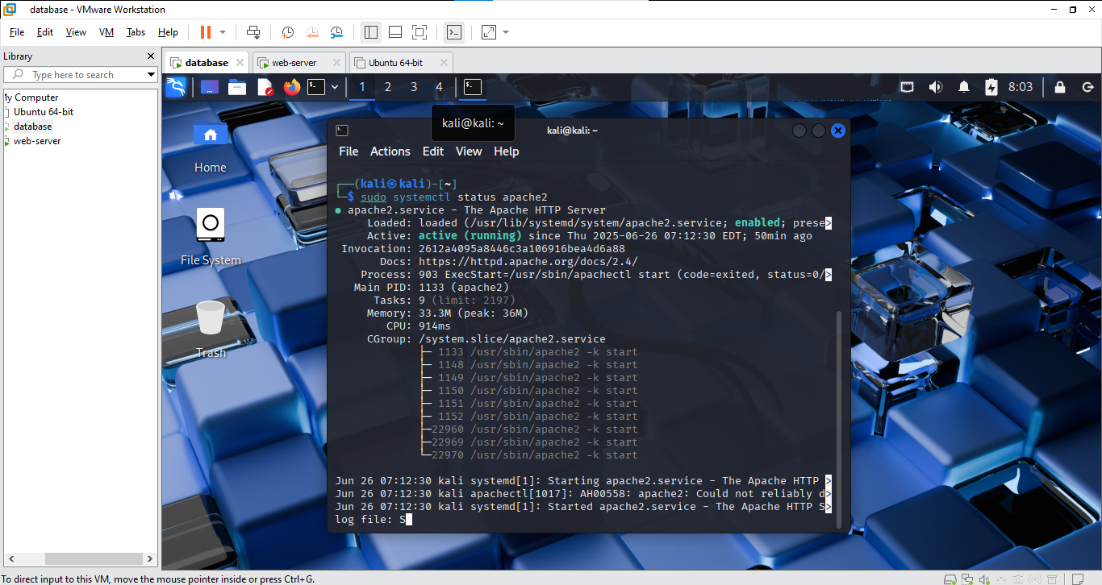

Step 3: Clone the DVWA Repository
cd /var/www/html
sudo git clone https://github.com/digininja/DVWA.git: to download DVWA from github
sudo chown -R www-data:www-data /var/www/html/DVWA: change the ownership of the directory to users in www-data group
sudo chmod -R 755 /var/www/html/DVWA: Set the permission of each type of user in the group(775 means owners can read, write, and execute the properties in the directory, while group members and others can only read and execute)

Step 4: Configure DVWA
cd /var/www/html/DVWA/config
sudo cp config.inc.php.dist config.inc.php: to copy the content of config.inc.php.dist to config.inc.php
sudo nano config.inc.php
Edit the following lines:
$_DVWA[ 'db_user' ] = 'dvwa';
$_DVWA[ 'db_password' ] = 'dvwa';
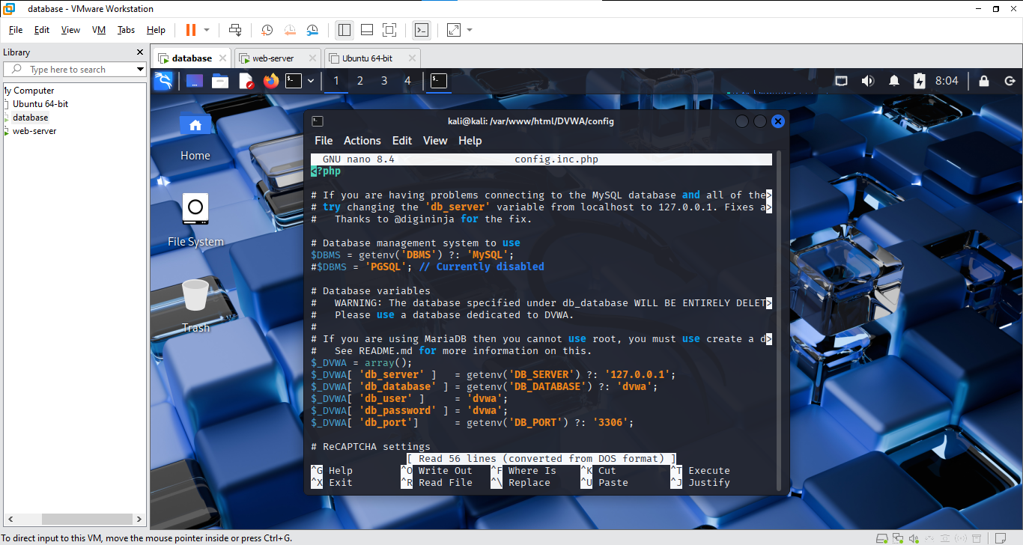

Step 5: Create the DVWA Database
sudo mysql
Then run:
CREATE DATABASE dvwa;: create a database named dvwa
CREATE USER 'dvwa'@'localhost' IDENTIFIED BY 'dvwa';: add a user named dvwa into the dvwa database
GRANT ALL PRIVILEGES ON dvwa.* TO 'dvwa'@'localhost';: give all permissions to the user named dvwa
FLUSH PRIVILEGES;: apply changes to the database
EXIT;
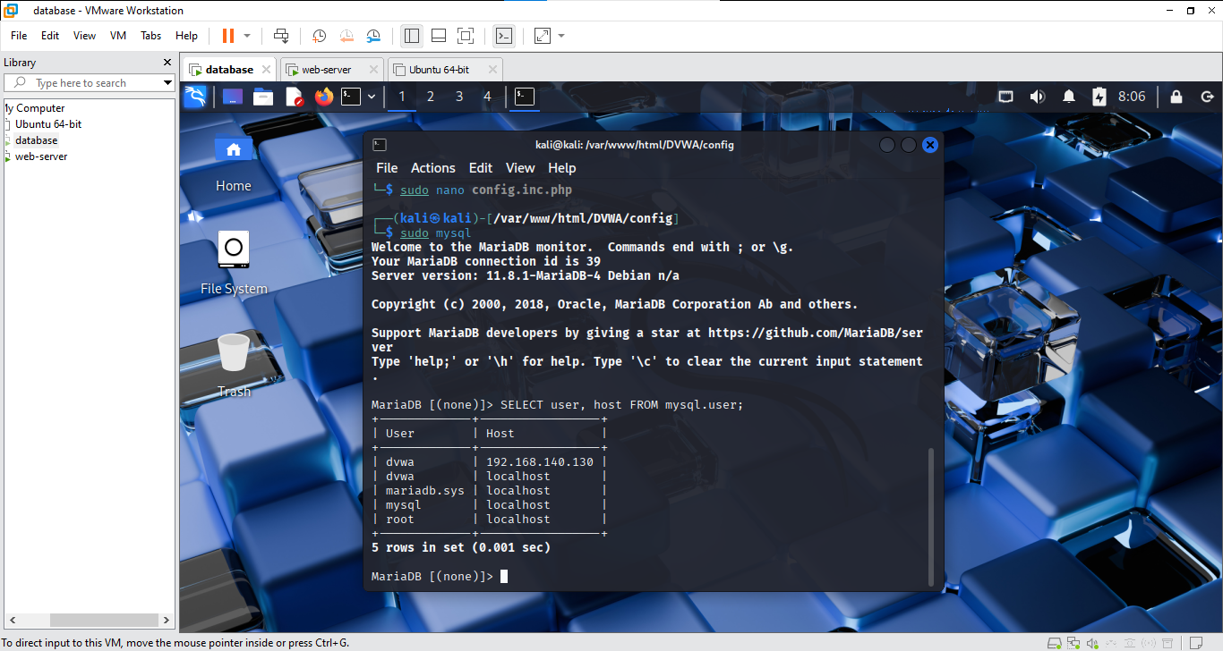

Step 6: Configure PHP
sudo nano /etc/php/*/apache2/php.ini
Find and set:
allow_url_include = On
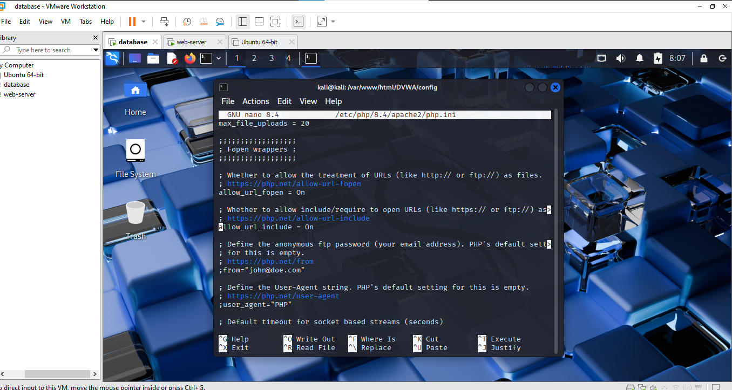
Then restart Apache:
sudo systemctl restart apache2

Step 7: Access DVWA
Visit: http://<your-server-ip>/DVWA/setup.php
Click 'Create / Reset Database'
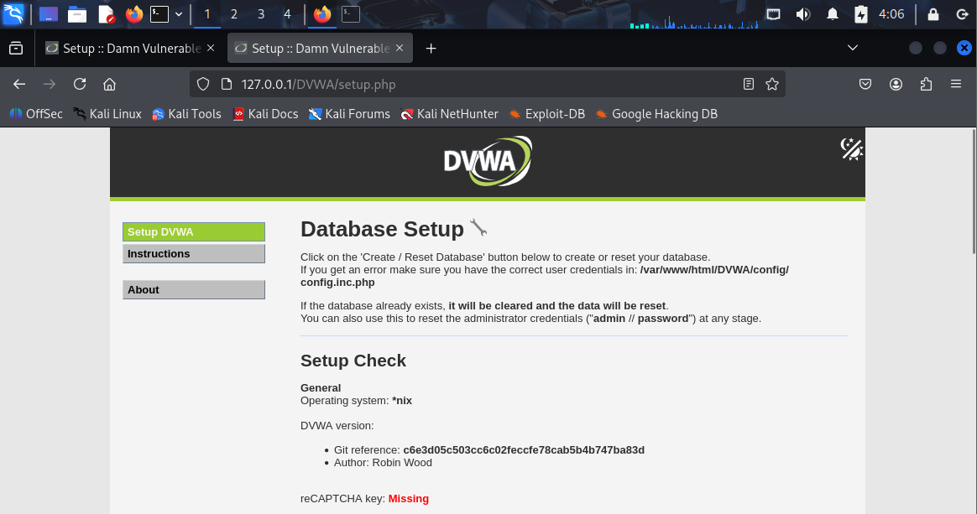
Then go to: http://<your-server-ip>/DVWA/login.php
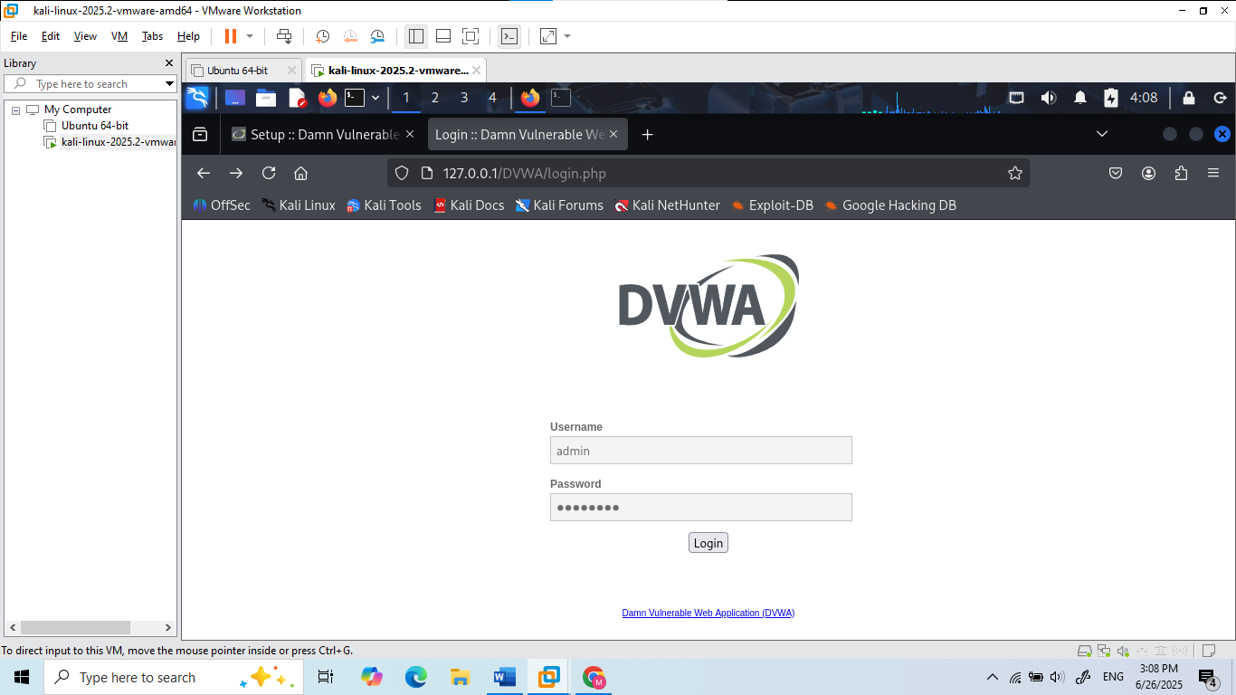

Login with:
Username: admin
Password: password 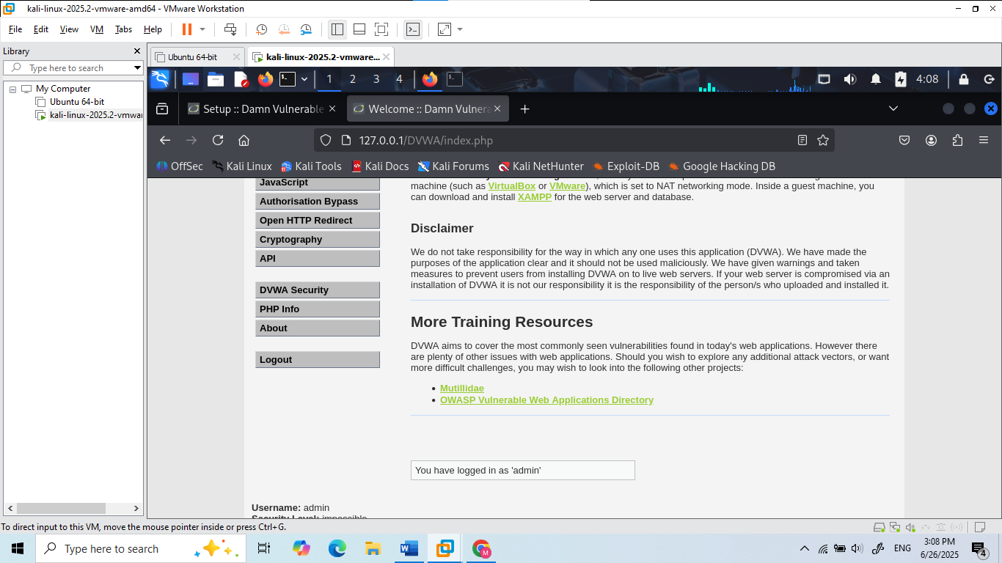

Step 8: Verification & Tasks
- Screenshot the DVWA login page
- Log in and set security level to 'low'
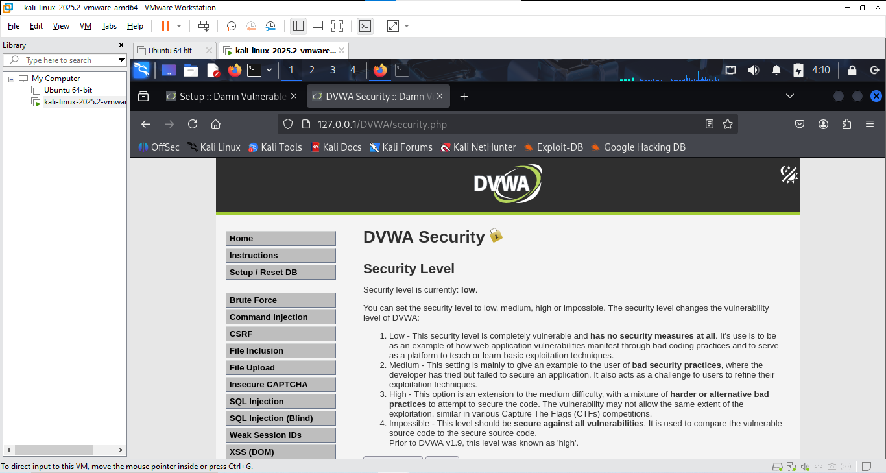
- Write a short reflection on why DVWA is insecure by design

PART 2. Deploying the website on 2 servers

Network Configuration
Example configuration (Students need to check the IP address of the Server):
- Web Server: 192.168.1.20
- Database Server: 192.168.1.30

Step 1: Configure Database Server
1. Update packages and install MariaDB:
sudo apt update && sudo apt install mariadb-server -y
2. Start and enable MariaDB:
sudo systemctl enable mariadb
sudo systemctl start mariadb
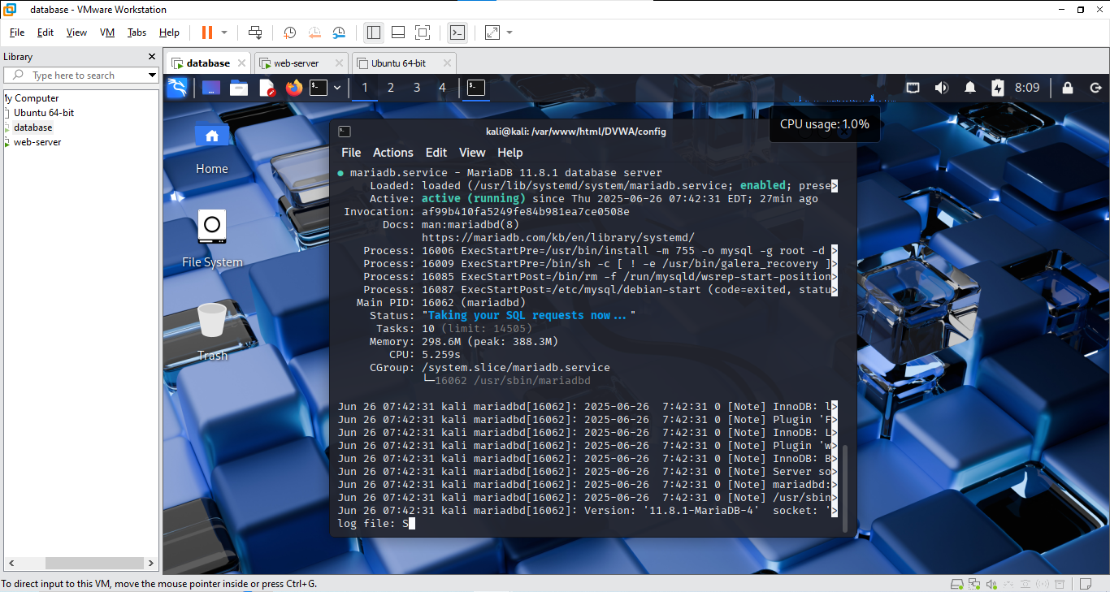
3. Configure the DVWA database:
sudo mysql
CREATE DATABASE dvwa;
CREATE USER 'dvwa'@'192.168.1.20' IDENTIFIED BY 'dvwa';
GRANT ALL PRIVILEGES ON dvwa.* TO 'dvwa'@'192.168.1.20';
FLUSH PRIVILEGES;
EXIT;
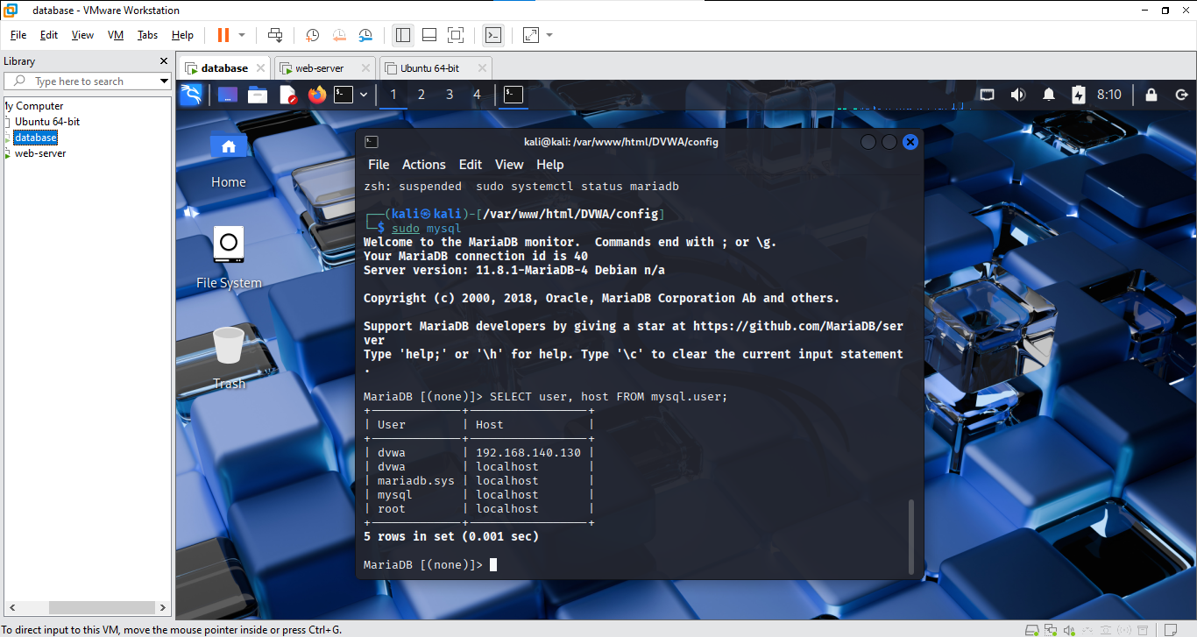
4. Allow remote connections:
sudo nano /etc/mysql/mariadb.conf.d/50-server.cnf
Change: bind-address = 0.0.0.0
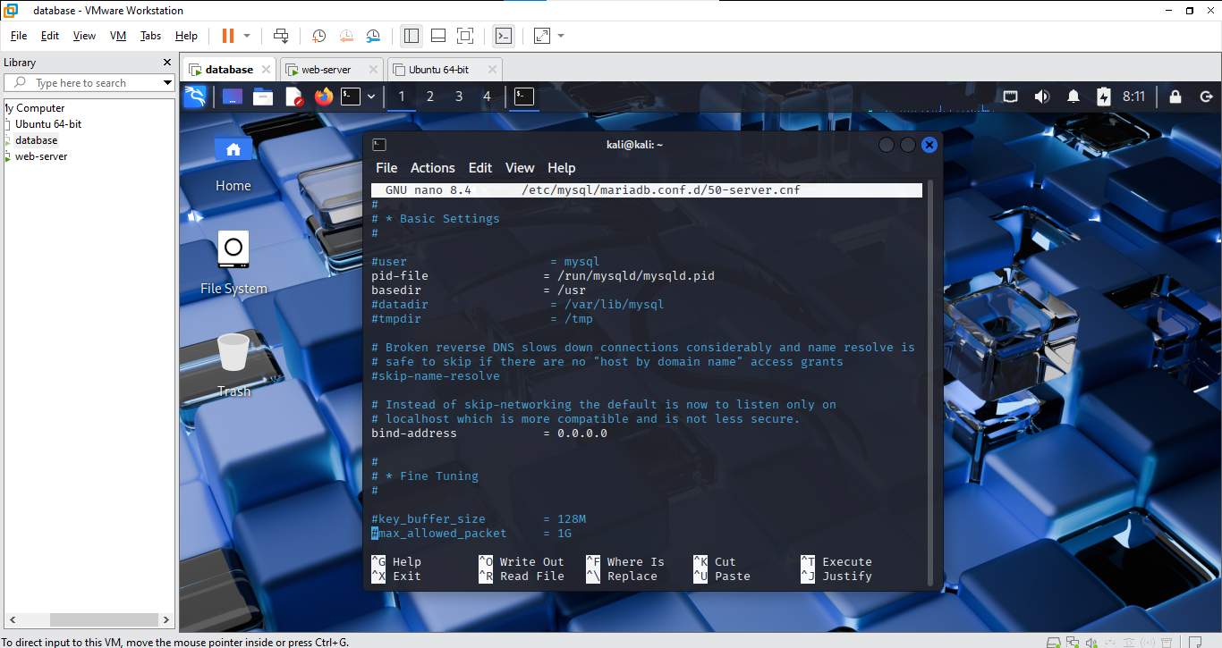
sudo systemctl restart mariadb

Step 2: Configure Web Server
1. Install Apache, PHP, and dependencies:
sudo apt update
sudo apt install apache2 php php-mysqli php-gd git -y
2. Clone DVWA into web root:
cd /var/www/html
sudo git clone https://github.com/digininja/DVWA.git
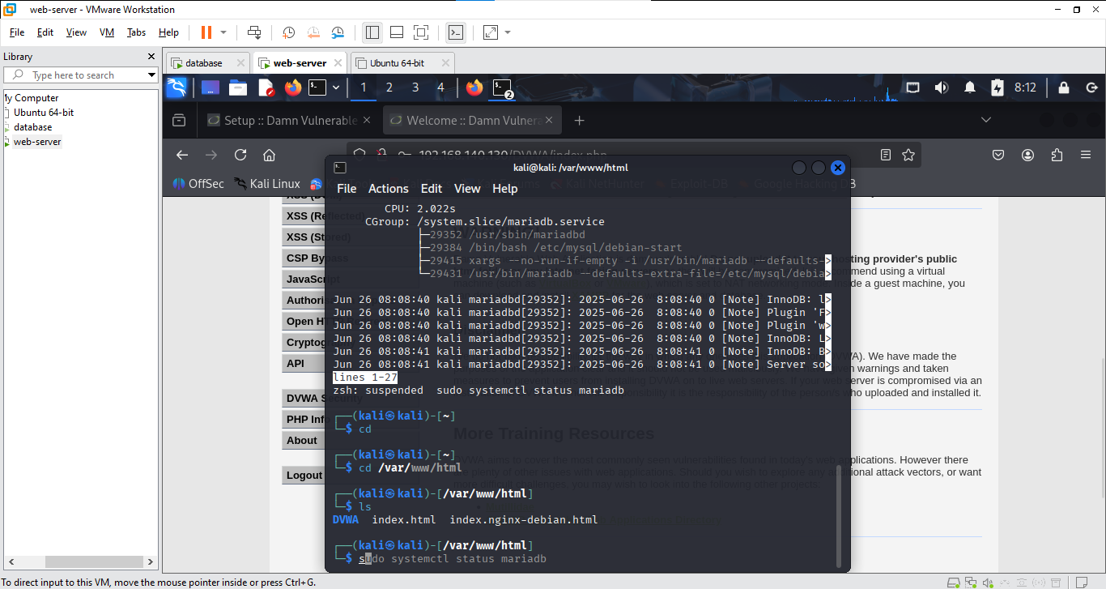
3. Set permissions:
sudo chown -R www-data:www-data DVWA
sudo chmod -R 755 DVWA
4. Configure DVWA:
cd DVWA/config
sudo cp config.inc.php.dist config.inc.php
sudo nano config.inc.php
Set:
$_DVWA[ 'db_server' ] = '192.168.1.30';
$_DVWA[ 'db_user' ] = 'dvwa';
$_DVWA[ 'db_password' ] = 'dvwa';
$_DVWA[ 'db_database' ] = 'dvwa';
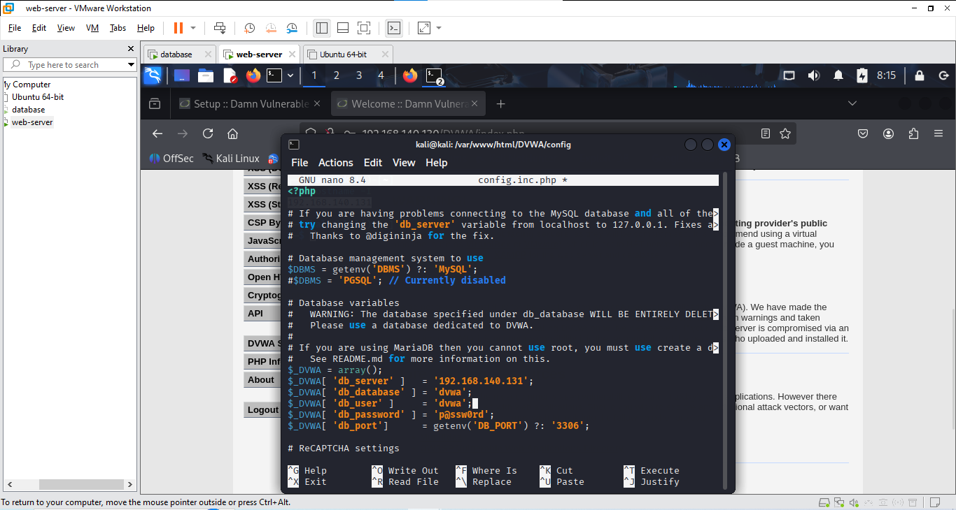
Ensure 'allow_url_include = On' in PHP config:
sudo nano /etc/php/8.4/apache2/php.ini
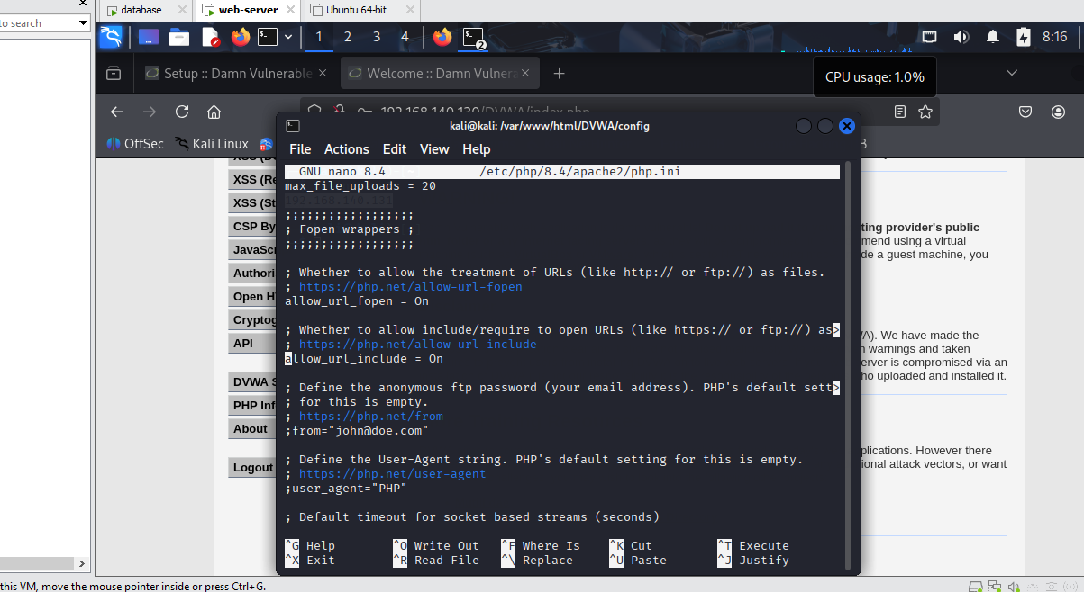
Then restart Apache:
sudo systemctl restart apache2

Step 3: Verify Setup
1. On the Web Server, open browser or client and visit:
http://192.168.1.20/DVWA/setup.php
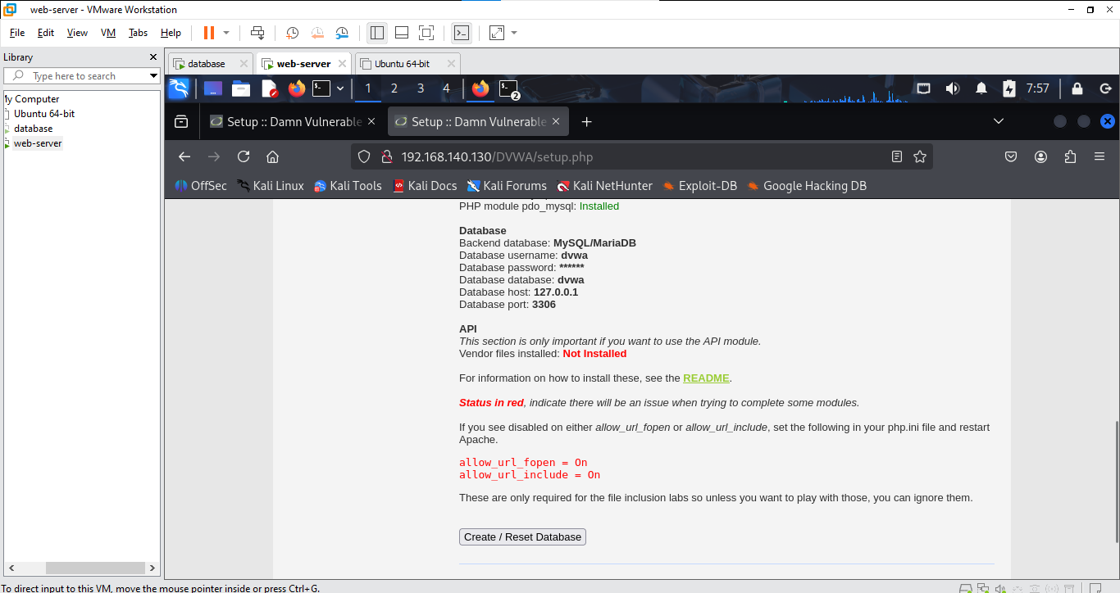
2. Click 'Create / Reset Database'
3. Then login at:
http://192.168.1.20/DVWA/login.php
Username: admin
Password: password
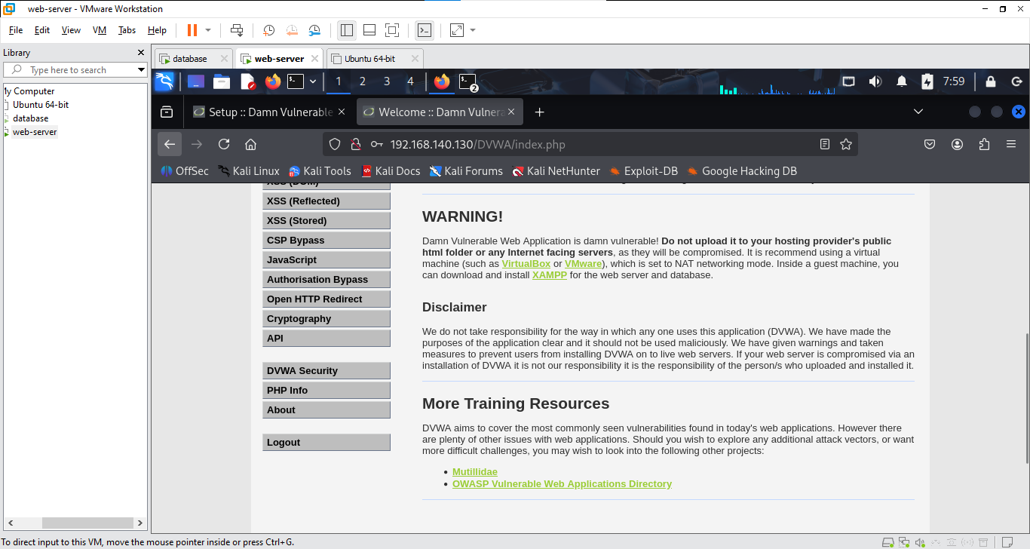

Common Troubleshooting Tips
- Ensure MySQL is listening on 0.0.0.0 s
- Use `telnet 192.168.1.30 3306` from the Web Server to test DB connection
- Check firewall (ufw or iptables) if services are blocked
- Check Apache and MariaDB logs for error details

Lab Report Submission

Students must submit:
- Screenshot of MySQL configuration and DVWA login page
- Evidence of IP setup and working DB connectivity
- A short explanation of each configuration step

